Installation Steps:
- Open new tab in Chrome type chrome://extensions and press enter.

- Drag and drop “OSNNotifications.crx” file into the tab opened in Step1.
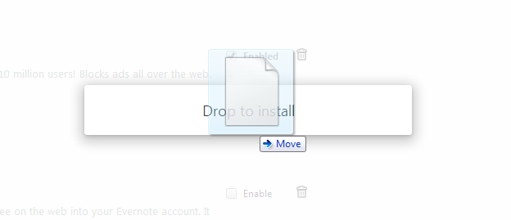
- Click on Add button in the opened popup.
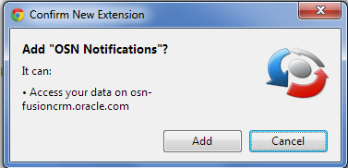
- If extension is installed successfully then one notification is shown and also an entry is added to extensions list.
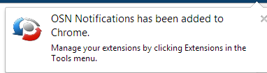
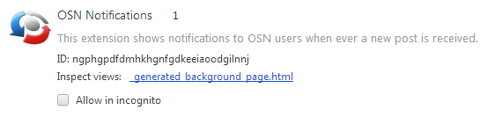
- Open OSN website in a new tab or refresh if it is already opened.
- Notification is displayed when ever user receives a new post.
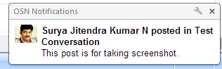
Uninstallation Steps:
- Open new tab in Chrome type chrome://extensions and press enter.
- Go to OSN Notifications extension and click on bin icon next to it.
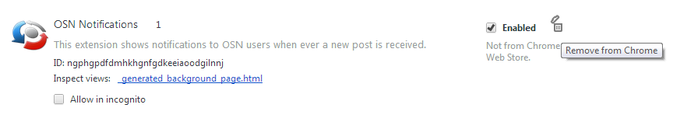
- Click on Remove button in the opened popup.
